HBL Power Systems Ltd, India | Technical Description for  relay interface box for 3ph-emu

TECHNICAL DESCRIPTION
FOR
Relay interface box (3PH EMU RIB) for 3ph emu

Document Number: 5 16 27 0055
Version: 1.0

Date Published: 06-01-2023

Prepared By
HBL Power Systems Limited
Hyderabad

This document and its content are the property of HBL Power Systems Ltd, who alone reserves the right for distribution use and reproduction

DOCUMENT DATA SHEET

Title of Document | File Name | Pages | Figures | Tables
Technical Description For Relay Interface Box for 3PH-EMU | Technical Description for Relay Interface Box for 3PH-EMU | 19 | 2 | -

Prepared by | Reviewed by | Approved by
D Lovaraju  (Engineer) | JVV Prasad  (Dy. Manager) | Y. Subrahmanyam  (Head -Engineering)

Abstract
This document describes the features and functions of the Relay Interface Box of 3PH EMU and explains the design of the same

DOCUMENT CONTROL SHEET
# | Name | Organization | Function | Level
1 | D Lova Raju | HBL | Engineering | Prepare
2 | JVV Prasad | HBL | Engineering | Verify
3 | Y. Subrahmanyam | HBL | Engineering | Approve

CHANGE HISTORY

# | Date | Reason for changes | Updated by | Version
1 | 06-01-2023 | Initial | D Lovaraju | 1.0

GLOSSARY OF TERMS
# | Abbreviation | Meaning
 | BC | Brake Cylinder
 | BP | Brake Pipe
 | MR | Main Reservoir
 | CAN | Controller area network
 | LP-OCIP | Loco Pilot Operation Cum Indication Panel
 | EB | Emergency Brake
 | FR | Functional Requirement
 | FSB | Full-Service Brake
 | LV | Limiting Valve
 | EMU | Electrical Multiple Unit
 | QRV | Quick-Release Valve
 | SR | Safety Requirement
 | ATP(TCAS) | Train Collision Avoidance System
 | 3PH EMU RIB | Relay Interface Box
 | EP | Electro Pneumatic
 | ATP | Automatic Train Protection System
 | BIC | Brake Interface Card
 | DC | Direct Current
 | AWS | Automatic Warning System

Table of Contents
1.0 SCOPE 8
2.0 PURPOSE 8
3.0 3PH EMU RIBFUNCTIONAL & SAFETY REQUIREMENTS 8
4.0 BRAKE APPLICATION ON LOCOMOTIVES 11
5.0 3PH EMU RIB DESIGN DESCRIPTION 11
6.0 3PH EMU RIB – Electrical Circuit 13
7.0 Electronics in VB 3PH EMU RIB 14
7.1 Brake Interface Card (BIC) 14
7.2 BIC power supply card 14
8.0 COMPLIANCE WITH SAFETY REQUIREMENTS 14
8.1 Fail Safety 14
8.2 Health Monitoring 15
8.3 Isolation 15
9.0 Dimensional details of 3PH EMU RIB 16
9.1 Without mounting arrangement 16
10.0 Technical Specification Sheets 16
11.0 Schematic diagram of ATP interface with an 3-PH EMU braking system 17
12.0 Block Diagram of Relay Interface Box for 3PH-EMU Locomotive 18

- SCOPE

  - This document relates to the design of 3PH EMU Relay Interface Box (3PH EMU RIB) for use on 3PH EMU locomotives and ATP systems like ATP.

- PURPOSE

  - KAVACH is designed to ensure safe train operation in the event of human failure by stopping or controlling the speed of trains.
  - For the sake of brevity, KAVACH will hereafter be referred to as ATP system.
  - It is necessary for ATP systems to be interfaced with the braking system of the Locomotive’s.
  - Under certain circumstances, it is also necessary to isolate the ATP system braking and allow the Loco Pilot to operate the Loco’s manually.
  - The purpose of this document is to propose the design of 3PH EMU RIB for ATP system that fulfills the above safety requirements.

- 3PH EMU RIBFUNCTIONAL & SAFETY REQUIREMENTS

  - The functional requirements of 3PH EMU RIB are listed below.
# | Requirements
FR-1 | 3PH EMU RIB shall work in parallel to the existing Locomotives braking system (controlled by the Pilot)
FR-2 | 3PH EMU RIB shall not modify the existing braking characteristics of the Locomotives
FR-3 | The 3PH EMU RIB shall have provision for executing following brake commands received from ATP  a) Full Service Brake (FSB) command  FSB –BP Pressure Drop to 3.5 ±0.1 kg/cm2 from 5.0 kg/cm2  b) Emergency Brake (EB) command  EB – BP Pressure Drop to 0 kg/cm2 from 5.0 kg/cm2
FR-4 | Based on the input signal received from the ATP system through 3PH EMU RIB, the existing brake control system shall apply the corresponding brake, as mentioned at FR-3 above.
FR-5 | Separate Relays shall be used for following brake applications  - Full-Service Brake  - Emergency brake  - QRV
FR-6 | On withdrawal of brake command from ATP system, the corresponding brake shall be released, and restoration of traction cutoff control shall be enabled.
FR-7 | There shall be a facility to override the "ATP system initiated braking" by the "driver’s braking" (or vice versa) to achieve higher braking intensity whenever required). Loco Pilot can override and increase braking effort generated by 3PH EMU RIB, but not decrease the same. Also, the lower braking intensity of ATP shall be overridden by a higher braking intensity produced by other train safety systems, if any. Arrangement for data logging for the above scenario shall be available.
FR-8 | 3PH EMU RIB shall be capable of receiving braking command simultaneously from the Loco pilot through Brake Controller handle as well as from the ATP system at the same time. In case of multiple braking requests received simultaneously, the 3PH EMU RIB should implement the command demanding for the highest braking effort.
FR-9 | 3PH EMU RIB shall have provision to obtain feedback from existing system about the execution of braking command given to it by ATP system and communicate it back to ATP system.
FR-10 | 3PH EMU RIB shall have a provision of point-to-point communication with ATP system.
FR-11 | The communication between the 3PH EMU RIB and the ATP system shall be on RS485. RS485 communication ports should have galvanic/optical isolation
FR-12 | There shall be provision for Isolation of the complete 3PH EMU RIB. Isolation shall be provided in case of malfunction. After isolation, the normal brake characteristics of the locomotive brake system shall not be affected.
FR-13 | The 3PH EMU RIB shall have the facility to isolate itself from the loco pneumatic system through an isolation cock. The isolation shall be achieved through isolation switch electrically operated by the 3PH EMU RIB.
FR-14 | The Brake unit isolation shall be monitored, and its status shall be communicated by 3PH EMU RIB to ATP system.
FR-15 | The 3PH EMU RIB shall have a non- re-settable counter to register the instances of brake unit getting isolated by the Loco Pilot.
FR-16 | The 3PH EMU RIB isolation switch shall be located on the 3PH EMU RIB such that it is accessible for operation by the Loco Pilot.
FR-17 | There shall be a provision of manual isolation of the 3PH EMU RIB. Pneumatic inlet pipe BP to 3PH EMU RIB shall be provided with isolating cock to the unit.
FR-18 | 3PH EMU RIB shall have a Self-Test feature for the detection of failed sensor by performing self-diagnosis at power ON and give alerts to a user through ATP system display. The 3PH EMU RIB shall have the facility to communicate its diagnostics information to ATP system.
FR-19 | 3PH EMU RIB shall have provision for redundant control for emergency brake command, which shall be activated if the default control mechanism fails
FR-20 | For any internal failure in 3PH EMU RIB, the following action shall be taken by 3PH EMU RIB.  - Brakes will be applied.  - System goes to failure mode.
FR-21 | All supply voltages for operating the 3PH EMU RIB shall be generated from loco battery which shall be in the range 78V to 136V DC

  - Requirements for data logging of braking events generated by equipment connected to communication ports (For ATP system).

# | Requirement
FR-22 | Recording of 3PH EMU RIB isolation event with date and time and number of counts of 3PH EMU RIB isolation.
FR-23 | Arrangement for data logging for the braking event shall be available with ATP. The status of following events shall be logged at 1-sec interval/change in events, with date and time stamp  - ATP brake command active  - Isolation of 3PH EMU RIB  - 3PH EMU RIB failure log  - Relays failure log  - 3PH EMU RIB brake command override by Loco pilot brake command, vice versa  - Any change in BP/BC greater than 0.3Kg/cm² to be logged
FR-24 | The facility for the storage of data log shall be for 90 days. An application running on PC shall be provided for downloading the Log and evaluating the same.

  - The safety requirements of 3PH EMU RIB are listed in the following table.

# | Requirements
SR-1 | The emergency brake command shall be fail-safe.
SR-2 | In case of power supply failure to 3PH EMU RIB, the emergency brake shall get activated.
SR-3 | In case of communication failure between 3PH EMU RIB and ATP System, the 3PH EMU RIB shall command emergency brake.
SR-4 | In case of critical failure of 3PH EMU RIB electronics interfaced with ATP System, emergency brakes shall get activated.
SR-5 | In the case of manual isolation of 3PH EMU RIB through the operation of BP cock, the isolation cock shall be provided with sensing input connected to 3PH EMU RIB to detect the external pneumatic isolation. This information shall be communicated by 3PH EMU RIB to ATP system to switch/change to the appropriate mode of operation.
SR-6 | There shall be a provision in 3PH EMU RIB to cut-off traction in locomotives automatically whenever brake command signal is received to 3PH EMU RIB (through ATP system). Also, this shall be withdrawn as soon as brake commands are withdrawn.

- BRAKE APPLICATION ON LOCOMOTIVES

  - The brake system on Locomotive's has Brake controller handler(A9), which the loco pilot uses to brake the locomotive.
  - The Brake controller handler is a compact self-lapping, pressure maintaining brake valve which is capable of gradual application or release of Locomotive's and train brakes. Brake controller handler automatic brake valve has four positions: Release, Auto, LAP and Emergency. In the release position, it provides a brake pipe pressure of 5 Kg/Cm2. In other positions, the brake pipe pressure is reduced to varying levels according to the required level of braking.

- 3PH EMU RIB DESIGN DESCRIPTION
  - In a locomotive, the Loco Pilot adjusts the position of brake controller handler lever to obtain the desired level of braking based on his situational awareness through sensory perception.
  - With automated or mechanized train systems, there should be an automated mechanism of controlling the brake pipe pressure to obtain the desired level of braking. The proposed 3PH EMU RIB design facilitates this automated mechanism, which is described in the subsequent sections.
  - FULL SERVICE BRAKE (FSB)
    - SERVICE BRAKE APPLICATION
      - In normal conditions, service brake relay will be in energized position.
      - Whenever there is a service brake command received from ATP system, service brake relay gets de-energized and FSB brake will be applied.
      - This service brake shall be required to use during SPAD prevention.

    - SERVICE BRAKE RELEASE
      - Whenever there is service brake release command from ATP, service brake relay will get energized to release the service brake.

  - EMERGENCY BRAKE (EB)
    - EMERGENCY BRAKE APPLICATION
      - In normal conditions, emergency brake (EB) relay in energized position and QRV relay in energized position.
      - Whenever there is an emergency brake command from ATP system, EB relay gets de-energized and QRV relay turns into de-energized position to open (exhaust) brake pipe pressure and emergency brake will be applied.
      - Emergency brake shall be applicable during system failures and train trips in overlap.
    - EMERGENCY BRAKE RELEASE
      - Whenever there is no emergency brake (EB) command from ATP system, emergency brake relay will be in energized position, QRV relay gets energized to close BP pressure.

    - For achieving fail-safe design, QRV relay is energized for normal operation. Whenever emergency braking is required, the relay is turned off and drops the supply to AWS valve. Therefore, if there is loss of electric power or communication with the ATP system, emergency brake is automatically applied.

  - TRACTION CUTOFF

    - TRACTION CUTOFF APPLICATION
      - In normal condition, Traction cutoff relay shall be in energized position.
      - Whenever there is a brake command (Service or Emergency) from ATP, the traction cutoff relay will be de-energized and “NO” contact becomes “NC” contact and traction power will cut-off.

    - TRACTION CUTOFF RELEASE
      - After brake command is released by ATP, traction cutoff relay becomes energized and “NC” contact becomes “NO” contact. Traction power will be allowed.

    - TRACTION CUTOFF RELAY PLACEMENT
      - This relay is fixed in the CAB INPUT Box and designated inputs will be taken from AWS.
      - These inputs will be connected to “NC” contacts of Traction cut-off relay.
      - These inputs may vary based on the Loco type.

- 3PH EMU RIB – Electrical Circuit
  - The 3PH EMU RIB electrical circuit consists of a micro controller based electronic brake interface card and an Isolation Switch.
  - Pressure sensor in critical areas of the braking system provide feedback to the BIC card for health monitoring and reporting.
  - For connecting with ATP System vital computer, a separate serial port based on RS485 interface is provided.
  - All the relays are controlled through software in the brake interface card. The relays are controlled by the 3PH EMU RIB as per braking commands received from ATP system. Therefore, these relays operate only when the 3PH EMU RIB is in service mode.
  - Whenever the isolation switch is in isolation mode relays are turned off by the brake interface card, thus isolating the 3PH EMU RIB from the Loco braking system. But the emergency valve remain in energized position irrespective of Isolation switch position.
  - The following table shows the conditions of each relay under various braking applications. Here, the letter E indicates that the relay is energized, while D indicates that the relay is de-energized.

Position | FSB  Relay | EB  Relay | QRV  Relay | Traction cut-off  Relay
A9-Release | E | E | E | D
A9-FSB Brake | D | E | E | E
A9-Emergency Brake | E | D | D | E
3PH EMU RIB isolation | D | D | E | D

- Electronics in VB 3PH EMU RIB
The figure below shows the interface of electronic modules in VB 3PH EMU RIB.

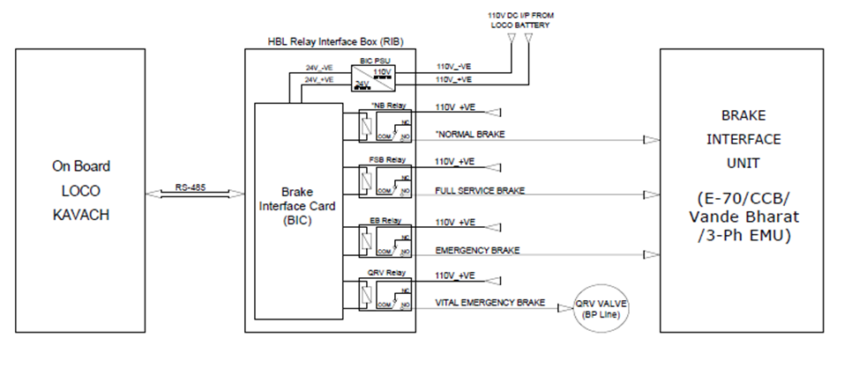

  - Brake Interface Card (BIC)
    - The brake interface card is the heart of the BIU system. This module is micro-controller based and performs the following functions.
    - The BIC card interfaces with ATP system on RS-485 communication link using optically isolated ports.
    - BIC drives the relays as per brake commands received from ATP systems.
    - For any brake application, the BIC card energies the corresponding relay which also cuts off traction. When brake is released, these outputs are withdrawn.
    - The air pressure in BP is sensed by BIC through pressure sensor.
    - BIC card Interfaces with an electromechanical counter for registering the number of times 3PH EMU RIB is isolated.
    - BIC receives feedback from BP isolating cock when operated (Open / Close).

  - BIC power supply card
    - BIC power supply card that converts the loco battery supply 110V to 24 volts DC output.
    - BIC power supply card is used for powering the relays and solenoid valves.

- COMPLIANCE WITH SAFETY REQUIREMENTS

  - Fail Safety
    - If there is loss of electric power, 3PH EMU RIB automatically applies emergency brake through the AWS valve.
    - If there is a loss of communication between ATP and 3PH EMU RIB, the 3PH EMU RIB will automatically apply emergency brake.
    - For any brake application, 3PH EMU RIB activates a control signal that is used externally in the loco system for generating traction cut off.

  - Health Monitoring
    - 3PH EMU RIB electronics circuit includes power supply health monitoring and appropriate corrective actions.
    - Heart-beat monitoring of pneumatic valves:
      - Brake Interface Card in 3PH EMU RIB monitors voltage and current of each energized relay for every 200ms.
      - If the voltage and current values of any relay crosses defined tolerance limits, the corresponding relay is flagged as unhealthy.
      - In such an event, ATP displays a message on the DMI that the 3PH EMU RIB is unhealthy (<BRAKE Fault>) and will apply Emergency Brake.
      - The same event will be logged in ATP System.

  - Isolation

    - The 3PH EMU RIB can be electrically isolated by the use of an isolation switch provided on the front panel of 3PH EMU RIB.
    - The isolation switch can be changed from service to isolation mode.
    - Upon isolation, the original pneumatic circuit of the loco will function under control of the Loco Pilot.
    - 3PH EMU RIB electronics will communicate to the ATP system that the 3PH EMU RIB had been isolated. This causes the ATP systems to switch to an appropriate mode of operation, as per ATP system specification. 3PH EMU RIB can also be isolated from the pneumatic system through operating cock installed in the BP line.
    - The isolation cock are provided with position feed back to the 3PH EMU RIB brake interface card to detect the pneumatic isolation and this information is communicated by 3PH EMU RIB to ATP system to change over to the appropriate mode of operation.

ATP will switch to Standby mode if the cock is not in respective positions. In this condition, ATP does not provide train protection features.

- Dimensional details of 3PH EMU RIB
  - Without mounting arrangement
The external dimensions of 3PH EMU RIB are 480(W) x 450(H) x 190(D) mm. The figure below shows the 3PH EMU RIB without the mounting arrangement.
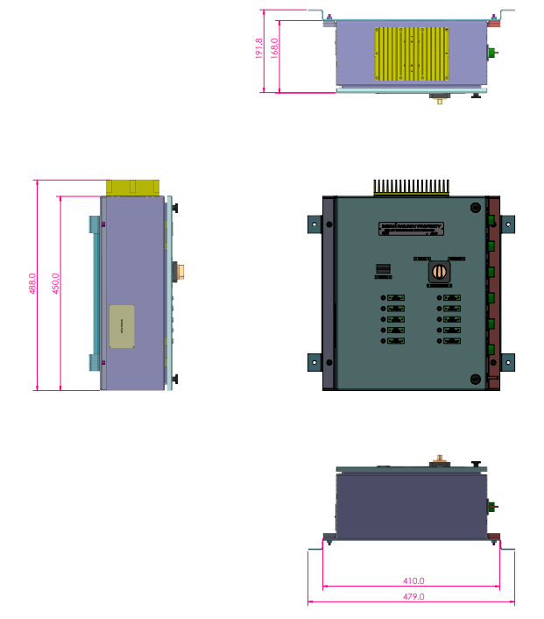

- Technical Specification Sheets

# | Item | Reference data sheet
1 | Relays | 
2 | Pressure Sensors | 

- Schematic diagram of ATP interface with an 3-PH EMU braking system
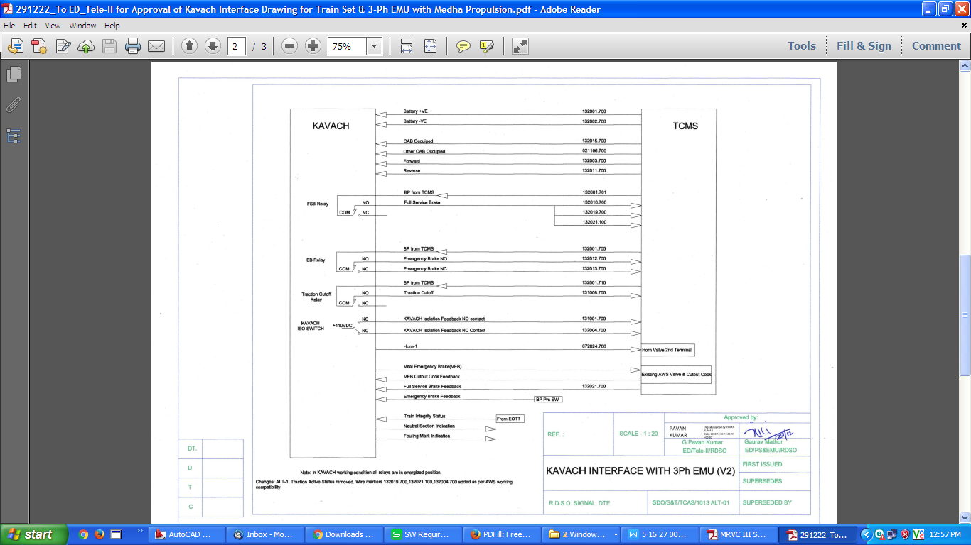
Figure 1: Schematic diagram of ATP interface with an 3-PH EMU braking system
- Block Diagram of Relay Interface Box for 3PH-EMU Locomotive
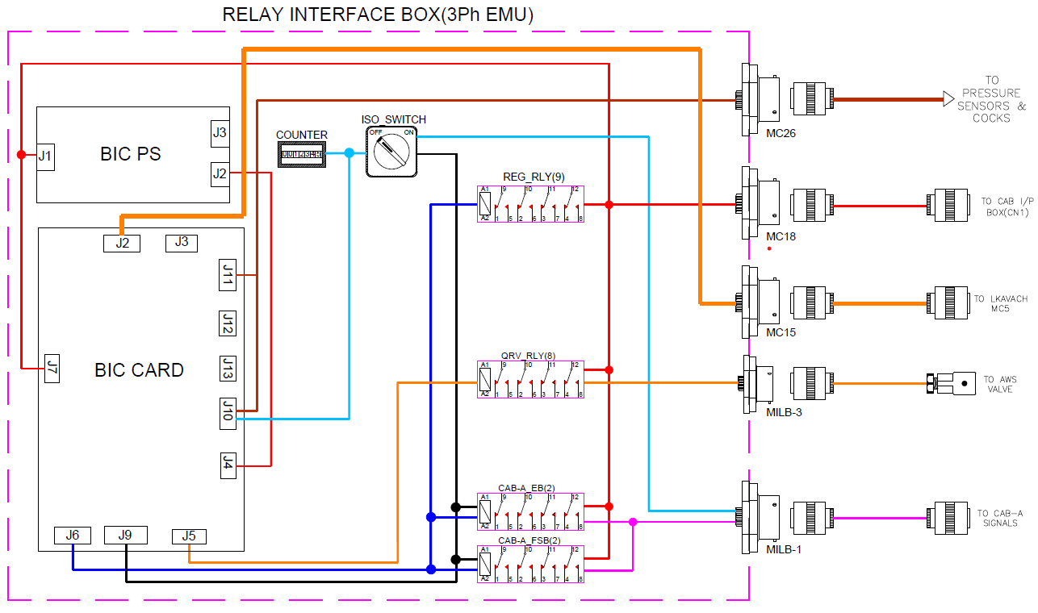
Figure 2: Block Diagram of Relay Interface Box for 3PH-EMU Locomotive

